SECTION 10 NONPOINT SOURCE NUTRIENT SIMULATION

10.1 Introduction to the Phase 5 Nonpoint Source Nutrient Simulation

10.1.1 Development of Nutrient Calibration Targets for Each Land Use
Edge-of-stream target loads are used for landuses as a start of the calibration process. Edge-of-stream target loads are used because little of the literature values of nutrient loads from the land are at the edge-of-field. This is in contrast to the estimates of sediment loads in Phase 5 where most of the load estimates are made with techniques like the USLE which are explicitly edge-of-field calculations. The literature values of nutrients often come from watershed studies where loads from a single or mixed landuse measured with in-stream concentrations.

Consequently, the use of transport factors relating edge-of-field nutrient load to edge-of-stream nutrient loads as in the case of sediments is unnecessary. The one exception is for nitrate loads in the coastal plain. Several papers have related lower nitrate loads from coastal plain land uses due to low gradient streams and permeable soils which allow longer and more effective denitrification rates in this region ( USGS Reference, 20XX; other reference 19xx; etc). This observed feature is empirically represented in the Phase 5 Watershed Model by reducing nitrate loads for coastal plain land uses by xx%.

Literature values are used and are represented by the maximum, minimum value, and median values, as well as the 25th and 75th percentiles. Usually nutrient loads are skewed upward, particularly for high loading land uses. The observed range from literature values is necessarily greater than the range of the Phase 5 Model estimated loads because the Phase 5 loads are based on the average land use condition for a land-segment (on the order of a county) and would therefore not have the potential for extreme soil, slope, and other conditions as seen in some of the literature values (Beaulac and Reckhow, 1982; Sweeney, 19XX.

The Phase 4.3 loads were also used as guidance as they were also based on literature values relevant to the Chesapeake region. The Phase 4.3 loads are represented in Figures 10.1 to 10.7. A particular gap filled in by the use of the Phase 4.3 loads as guidance is time. The synthesis papers look at literature for land uses like cropland studies in the 1970’s and 1980’s (Beaulac and Reckhow, 1982) to more recent periods (Sweeney, 19XX; Alexander et al., 2001). Agriculture is a dynamic industry with changing practices and standards and the use of the Phase 4.3 data set which characterizes Chesapeake watershed land use loads from the years 1985 and 2000 allows an average of the eighteen years of agriculture to be used for the target. Consequently, the Phase 4.3 data set of estimated nutrient loads helped us frame the midpoint of the calibration period 1992, the average of estimated 1985 and 2000 loads, to be used as the nutrient target.

Targets are given here as a single value but ranged in the calibration over an allowed degree of variation, usually variation driven by differences in hydrology or nutrient inputs (Figures xx.x to xx.x). When referring to a specifically defined Phase 5 land use the name is in italics. This is to avoid confusion with the general land use type. For example the Phase 5 forest, woodlots and wooded land is a specifically defined Phase 5 land use as distinct from the general landuse of forest land.

10.1.2 Basic Approach
The basic approach we adopted was to take the literature values as a median and then use a mass balance of inputs to get the estimated EOS load target based on the relative amounts of the input nutrients from fertilizers, manures, and atmospheric deposition. As application loads increase from these sources the nutrient export of nutrients increases. This allows a land use with high total input loads to get relatively high estimated nutrient targets and a land use with relatively low loads to get a lower target.

10.1.2.1 Basic Approach used in Forest, Woodlots, and Wooded Land Use
For example the forest, woodlots, and wooded land use has only atmospheric deposition as an input load. We assumed that the average forest TN load is 2 lb/ac/yr and that that generally occurs with the average atmospheric deposition in the watershed of about 21 lb/ac/yr . We further assume a response to an increase of atmospheric deposition to be linear so that if the atmospheric deposition was twice that of the average deposition the export of nitrogen would double (Equation 10.1.2). A linear response is consistent with the literature under moderate levels of nitrogen loading to forest. At high levels of atmospheric deposition nitrogen saturation occurs and the rate of export increases faster than the rate of deposition increase (reference here).

Equation 10.1.2.1:
forest, woodlots, and wooded = 2 lb/ac/yr * land-segment atmospheric deposition
total nitrogen export average TN Watershed average atmospheric deposition
export

The phosphorus loads from the forest, woodlots, and wooded land use don’t have variable inputs so a constant export target of 0.1 lb/ac/yr for total phosphorus is used everywhere.

10.1.2.2 Basic Approach used in Crop Land Uses
In the case of crop land uses the situation is more complicated by the additional inputs of fertilizers and manures. Fortunately we also have the Agricultural Censuses estimates of crop yields by county for the different crop types which allow us the opportunity to make adjustments in a nutrient balance for good and bad years of production as well as for land-segments that are more or less productive.

Overall the nutrient balance for a crop land use in a land-segment is defined as Equation 10.1.2.2.

Equation 10.1.2.2:

nutrient balance for cropland = Inputs (fertilizer, manure, atmospheric deposition) – Uptake

Average balance is literature mean export
Zero balance is ½ literature mean export

Literature medians are:
 | TN | TP
alf | 5.5 | 0.7
hom | 23 | 2.5
hwm | 23 | 2
hyo | 4 | 0.4
hyw | 6 | 0.8
lwm | 23 | 2
pas | 4.5 | 0.7

10.1.2.3 Basic Approach used in Developed Land Uses

Developed: Assumption is a constant concentration for TP and TKN with a variable concentration of NO3
TP = flow * 0.27 mg/l

Urban TN:

For impervious, the TN concentration is the TKN concentration
which is the average TKN concentration times the atmospheric deposition divided by the average atdep
For pervious the TN concentration = sum of TKN + NO3 concentrations where
TKN = average TKN concentration times the atmospheric factor
no3 = 0.8 times the atmospheric factor
the atmospheric factor is half the deviation of the impervious factor
The average TKN factor is the TKN that gives a model domain average TN of 2.0 when pervious has an average NO3 of 0.8 and impervious
has an average NO3 of 0.0 calculated as follows
 | Pr | Pervious water runoff
 | Pa | Pervious area
 | Ir | Impervious water runoff
 | Ia | Impervious area
 | Mass Balance
 | ([TKN] + [NO3]) * Pr * Pa + [TKN] * Ir * Ia = [TN] * (Ir * Ia + Pr * Pa)
 | solve for TKN
 | To make it more accurate, include the atmospheric factor in PrPa and IrIa

10/27/08 USE A GRAPHIC HERE TO DESCRIBE THIS AND EXPAND TEXT.

10.1.3 Nutrient Uptake Preference
The nutrient uptake preference is generally set at an 80% preference for nitrate and an associated 20% preference for ammonia in Phase 5. This means that in the HSPF simulation the DIN nutrients will be taken up by plants in a nitrate to ammonia ratio of 4/1 or with respect to the nutrients in soil available to be exported to rivers, the nitrate storage will be drawn down more than the ammonia storage and thus shift the balance toward the export of ammonia (all else being equal). Nutrient uptake in plants is complex and much needs to be still understood, although it's clear that there are two separate and largely independent pathways of uptake for nitrate and ammonia (Tinker and Nye, 2000). Using ¹⁵N tracers to track nitrate and ammonia uptake in plants, other researchers have described terrestrial plants communities having a significantly higher uptake of nitrate in dryer areas and a significantly higher ammonia uptake in wetter areas (Macko et al., 2005). Due to the potential variation in the general pattern of nutrient uptake, the uptake preference was allowed to vary slightly in the calibration if a better calibration can be achieved with a nutrient preference other than the standard 4/1 nitrate/ammonia preference.

10.1.4 Use of Crop Yield Data
In order to realistically simulate nutrient export from agricultural lands in the Bay watershed, several parameters need to be modeled effectively, particularly the amounts and rates of crop uptake, as this is the fate of most of the nutrients applied to agricultural lands. Important also are soil nutrient balances, mineralization rates of various nutrient species, the effect of droughts, and nutrient wash off.

The response of cropland to key BMPs such as nutrient management and other BMPs that seek to limit applied fertilizers and manures to appropriate agronomic rates is another important calibration. Management practices that manage nitrogen and phosphorus loadings include manure transport programs, “precision agriculture”, cover crops, nutrient trading, carbon sequestration, and a mass balance of edge-of-field loading rates.

Several analytical techniques are used in order to accomplish these goals. A comparison was made between data from the Agriculture Census and NASS long-term yield data. “Nutrient Management Scoping” – observing model responses to various theoretical loading rates – was also performed. Model sensitivity to variations in the timing of nutrient application were also tested.

Data from the Agriculture Census, as well as soil survey data was used to estimate the maximum yield potential. A new, more robust query application from NASS allows for annual crop yields by county as far back as 1896. This provides a comparison between modeled annual crop yields. It also enhances the ability to estimate recommended nutrient management rates by county, and provides over 9,000 new calibration points for the model.

[ FOR THIS SECTION WE CAN USE SLIDES FOR ROB’S APRIL 2006 MOD SUB MEETING As of May 2006 overall, the model slightly over-predicts crop yield. The drought stress calibration parameters need to be slightly increased. The model is also sensitive to over-application. It was also determined that legumes affect nutrient availability on composite crops, and plague and pestilence cannot be captured by the model.

Nutrient management scoping was performed in the following manner: modelers calibrated non-nutrient land uses, then copied various soil parameters to nutrient management counterparts within the model. The nutrient management loading rates were about 30% lower than the rates of non-nutrient management land uses. However, the overall trends in crop yield were nearly identical: nutrient management yields were about 10% lower then non-nutrient management for non-manure receiving land uses. The nutrient management target yields are to be re-evaluated with new NASS data. In terms of manure receiving land uses, they were about 50% lower on nutrient management. Manure application timing and estimated loss may need to be re-evaluated, and organic mineralization may need to be increased in the model.

In general, the Agricultural Model shows a great potential for representing realistic yield trends. Some minor corrections need to be performed to increase the robustness of the model simulations, but management practices such as nutrient management are being realistically represented thus far.]

10.2 Development of Edge-of-Stream (EoS) Land Use Nutrient Targets
Models involve choices, and the choices in setting the nutrient targets are from a collection of observed values described in the literature that are always too few, combined with what ever meager professional judgment we’re given as light to see, and a sea, an ocean, a world, of uncertainty. The values given here as targets are represented as an overall average, something for the model to initially shoot for within a defined range of variance often driven by the spatial variation in input nutrient loads. These initial target often are adjusted by observed stream data during the calibration process. The targets suggested here are not represented as correct, but as “correctable” with more detailed local data for land use within each segment always to be desired, though rarely obtained. As we have more than 300 land segments and 24 land uses, we can only try to represent a broad watershed characteristic of the export of nutrient loads from each simulated land use.

An EoS nutrient target is used for nutrients rather than the edge-of-field targets used in the sediment simulation because effective methods to relate nutrient loss to distance from a simulated HSPF river for the entire Phase 5 domain are unknown. In addition, much of the nutrient export is on a watershed basis and is consistent with an edge-of-stream approach.

10.2.1 Forest, Woodlots, and Wooded Areas EoS Nutrient Targets
The Phase 5 forest, woodlots, and wooded areas land use covers woodland, woodlots, and usually any wooded area of 30 meters by 30 meters remotely sensed by spectral analysis. The forest, woodlots, and wooded areas land use is the predominate land use in the Chesapeake watershed. A good portion of what would normally be considered developed land falls in the forest, woodlots, and wooded areas category, examples being wooded urban parks and wooded low density residential areas. Even heavily urbanized areas have considerable land use of forest, woodlots, and wooded areas. For example, within the city boundaries of the District of Columbia and Newport News, VA there are 10% and 26% respectively of land in forest, woodlots, and wooded areas in the Phase 5 Model.

Beaulac and Reckhow (1982) estimate the annual average forest and woodland total nitrogen export loads to be about 2.2 lb/ac-yr based on about 8 studies. Beaulac and Reckhow report the range of total nitrogen export to be about 1.2 to 5.4 lb/ac-yr. Alexander et al. (2001) report SPARROW Model forest nitrogen load estimates of 1.8 to 11.2 kg/ha-yr and literature values of 0.1 to 10.8 kg/ha-yr. This is consistent with the Sweeney literature review (2001) which found a median total nitrogen export of 2.2 lb/ac-yr with a range of 0.1 to 9.1 lb/ac-yr from 17 publications of forest load estimates. Hunsaker et al. (1993), in her literature synthesis of forest nitrogen loads, had similar rates when highly loaded (20 to >90kg/ha-yr) European forests were excluded from the data. The Phase 4.3 estimated loads for Chesapeake watershed forests has a median value of 1.7 lb/ac-yr.

For Phase 5 a median value of 2.0 lb/ac-yr total nitrogen export was chosen to represent forest, woodlots, and wooded land which is consistent with the literature (Campbell, 1982: Langland et al., 1995; STAC, 1997; Ritter et al., 1984; Stevenson et al.1987; Nixon, 1997; Riekerk et al., 1988; Clark et al., 2000; Goodale et al., 2002; Pan et al., 2005) and consistent with Phase 4.3 (Figure 10.1). Total nitrogen loads from forest and woodlots decrease with decreasing nitrogen from atmospheric deposition. Increasing nitrogen deposition loads increase nitrogen export from forests, woodlots, and wooded land uses, particularly after a high load threshold is reached consistent with Aber et al., (1989, 2003).

Hunsaker et al. (1993) describes three studies in the Chesapeake watershed of largely forested catchments of Stony Creek (PA), Young Womans Creek (PA), and Rhode River (MD). In these forested catchments ammonia, nitrate, and organic nitrogen concentrations were measured and the annual average fluxes were estimated. Based on the average of these studies the target splits of ammonia, nitrate, and organic nitrogen are 11%, 38%, and 51% respectively. Based on the high portion of subsurface flow in wooded land uses, and with little literature as guidance, we arbitrarily assume that 90% of the nitrogen loads of each species are from subsurface export. We further assume that all exported organic nitrogen is dissolved and is slit into 50% surface and 50% subsurface and, following Hunsaker et al., that about 5% of the dissolved organic nitrogen is labile in the surface and subsurface export.

The labile and refractory organic nitrogen terms need more definition. In the Phase 5 Watershed Model labile organic nitrogen is nitrogen that acts like the reactive organic nitrogen measured in a BOD₅. The use of this particular arbitrary split between labile and refractory organics has several distinct advantages. The first is that a consistent labile and refractory split can be used throughout the model for all nutrient loads either from land, in rivers, or discharged by a pipe. The use of BOD₅ is important for point source loads where BOD₅ measurements are common. Also, BOD₅ is perhaps the most common of the uncommon finds of organic nutrient measures in the literature. The five day time of the BOD₅ measurement is consistent with the maximum time of travel in the simulated rivers of the Chesapeake watershed and within a five day period the labile organic nitrogen may react within the model domain, or if not, simply acts as if it’s refractory as the reaction time exceeds the average residence time of the model, at least for river waters. Using this as a definition limits the values labile organic nitrogen may take on in the targets. In the forests the reservoir of organic nitrogen is large, about two tons per acre (Hunsacker et al, 1993). Of this reservoir about 2% to 7% is mineralized each year. Accordingly, in our forest simulation we assume the bulk of the organic nitrogen exported is refractory (95%) and that only a portion (5%) is labile. Relatively more of the simulated forest nitrogen is considered refractory relative to other land uses due to observations that anthropogenic organic nitrogen is more bioavailable than forest derived organic nitrogen (Seitzinger et al., 2002a, Wiegner et al., 2006).

Literature values of total phosphorus range from 0.01 to 0.9 lb/ac-yr and have a median value of about 0.10 lb/ac-yr, and this is the target load used in Phase 5. The median total phosphorus export from Phase 4.3 wooded lands are lower, with a median value of 0.02 lb/ac-yr. A commonly used cellular ratio of nitrogen to phosphorus (by weight) is about 10-to-1, which would argue that almost all of the observed total phosphorus export is organic. Following the organic nitrogen splits, one half the organic phosphorus is assumed to be associated with the surface and one half with the subsurface and that 5% of these surface and subsurface organic phosphorus pools are labile. A small portion, 5% of both the surface and subsurface phosphorus load exported, is further assumed to dissolved inorganic phosphate. Forest total phosphorus exports will be largely unchanged by management actions as few BMPs exist to reduce forest phosphorus loads, as silviculture BMPs are applied to the harvested forest land use.

The target loads of forest were varied in order to allow those forest with high atmospheric deposition loads to have a higher nitrogen export consistent with our understanding of forest nitrogen dynamics (Abner et al. 1989, 2003; Stoddard, 1994). The relationship between atmospheric deposition of nitrogen and forest load export is shown in Figure 10.1. Loads of phosphorus are fixed at the median value of 0/15 lb/ac-yr as loads from atmospheric deposition are consistent and small.

10.2.2 Harvested Forest EOS Nutrient Targets
Harvested forest has a higher nutrient loading rates due to a multitude of landscape changes. Surface and subsurface flows are increased in harvested forest areas due to the reduced evapotranspiration as well as the reduced interception storage (Wang et al., 2003; Arthur et. al., 1999; Riekerk et al., 1988; Frick and Buell, 1999). More flow is available for nutrient export, but microbial mineralization rates also increased as direct sunlight on the forest soils increase soil temperatures. The reservoir of nutrients is estimated to be on the order of about two tons of organic nitrogen in forest soils and an equivalent amount of organic phosphorus (Hunsaker et al, 1993). The higher flows and microbial rates increase the inorganic nutrient export from harvested forest. At the same time, erosion increases due to disturbed soils, decreased evapotranspiration, increased runoff volume, and decreased canopy cover, which increases the impact energy of raindrops (Wilson et al., 1999; Grace, 2004; Hewlett, et al.,1979; Keppeler et al., 2003; Perry, 1998).

Observations of nutrient export vary widely (Arthur et. al., 1998; Riekerk et al., 1988; Lebo and Herrmann, 1998; Ensign and Mallin, 2001; Goodale et al., 2002). Arthur et al. (1999) describes an order of magnitude increase in nitrate loads from harvested forest and a doubling of phosphate loads. This is substantiated by Riekerk et al. (1998) who adds that organic nutrient loads increase about 6-fold and ammonia increases about 2-fold over that of undisturbed forest. The Phase 5 nutrient export targets for harvested forest reflect these reported nutrient loads with an estimated total nitrogen annual export load of 20 lb/ac-yr to the edge-of stream (EoS) and an estimated total phosphorus annual export load to the EoS of 0.8 pounds/acre-year. The higher loads from harvested forest are primarily due to the disturbance of the forest soil and reservoir of soil organic nitrogen and are a single fixed target value for all harvested forests.

The period of time the disturbed forest exports this high nutrient load is another problem for the HSPF structure. The literature suggests that a return to nutrient export rates of undisturbed forest occurs after about three to five years (Arthur et al., 1998; Castro et al., 1997). With only two wooded land uses of forest/woodlot and harvested forest, simulating the slow return of nutrient exports to the undisturbed forest rate is impractical and simplifying assumptions have to be made. Accordingly, the harvested forest nutrient export rates are applied in the simulation for the area of harvested forest for three years, including the first year of forest harvesting and in subsequent years revert to an undisturbed forest rate of nutrient export. In effect this means that the land use of harvested forest is three times that estimated to have been harvested in any particular year. With an estimated forest harvest rate of 1% of forest per year, 3% of the forest, woodlot, and wooded land use is simulated as harvested forest in order to simulate the period of forest harvest and recovery.

10.2.3a. Agricultural Targets
Agricultural edge-of-field targets are scaled against literature values based on a calculated residual remaining after crop removal. The assumption is that the median literature value for edge-of-field values represent the median edge-of-field value for the Chesapeake Bay watershed.

Edge-of-field estimates were calculated based on a mass balance of known inputs and outputs on the various land uses. These edge-of-field (EoF) balances were then compared to literature review of in-stream concentrations assigned “back-stream” to likely upland sources, to determine estimates of attenuation/delivery factors in lower order streams (literally, between the edge-of-field, and edge-of-stream since the scale of the phase 5 model is more watershed scale than field scale). Not only does this assist us in getting realistic values flowing into the reach portions of the model, insuring a reasonable calibration of modeled in-stream attenuation, it also addresses uncertainty in input/output estimates in the mass balance.

The mass balance on pervious surfaces was calculated based on the following data:
- Inputs: Fertilizer (I_{F}), Manure (I_{M}), N-fixation (I_{L}), Atmospheric Deposition (I_{A})
- Outputs: Crop Removal/harvest (O_{H}), de-nitrification/volatilization (O_{V}), attenuation in lower order streams (O_{A})
- Residual (E): Nitrogen (mobile) and Phosphorus (mobile and immobile)
- The residual, E, is that which may reach the stream

Since all studies that were used in the literature review took values that were at a watershed outlet, it was hypothesized that these values would involve significant attenuation of nitrogen, and possible retention of phosphorus and sediment. CBP performed an analysis comparing the total annual loads at numerous monitoring points to the sum of all upland land use acres (from the CB watershed model) multiplied by the median EOS values for those land-uses ( i.e., CB watershed model targets, from the literature review ), to estimate what the watershed model would predict if these edge-of-stream values were used as EoF values, and there was no modeled in-stream attenuation. This comparison showed that the predicted loads were between 0.4 and 0.6 of the monitored loads for nitrogen, and near unity (0.9 - 1.1) for phosphorus and sediment. This indicated that roughly 40-60% attenuation of nitrogen was occurring in the basins from which land use specific literature review values were derived. It also indicated only a small amount of retention of phosphorus and sediment in these studies. The attenuation values in this analysis are similar to those in a separate study by Rutgers University (Seitzinger et al, 2002b), which showed that between 37-76% attenuation of N would be predicted in various large rivers (both within and outside of the bay watershed) from a regression model (based on monitored values) of stream nitrogen concentration as a function of in stream travel time and stream depth. Similarly, the annual mass balance in agricultural land uses in the watershed model inputs, comparing estimated annual application rates with reported crop removal showed that the expected annual residual nitrogen (not removed by crop) would be approximately 2-3 times the amount in the literature review EoS, supporting the notion that considerable attenuation would occur between the edge of field and watershed outlet. Seitzinger et al, reported that approximately half of the attenuation of nitrogen should occur in 1st-4th order streams, therefore, the edge-of-field targets for model river segments was set to approximately 2x the literature review value, given that the average river segment is 4th order or less – in other words, effectively allowing for 50% of attenuation to occur within the modeled reaches that are > 4th order. It should be noted that the land module is effectively accounting for some nitrogen attenuation that happens in lower order streams, and that if model resolution were to be increased (i.e. smaller land units), the edge of field targets should be modified to decrease the attenuation, as the stream network would be expected to attenuate more nitrogen.

Since the mass balances varied greatly by county, there was no one EoS value that would work for a particular land use. Instead, the range of calculated mass balances were scaled to meet the range of reported literature values. Given the spatial aggregation of the modeling scale, it was assumed that the most extreme values from the literature review were representative of an anomalous field driven, or event driven circumstances, and therefore only the upper 75% and lower 25% values from the lit review were considered to bound the model EoS targets. Figure 10.2.1.4.1 shows a graphical depiction of the translation from calculated mass-balance to monitored EoS.

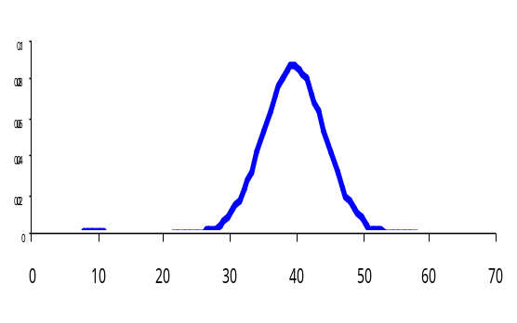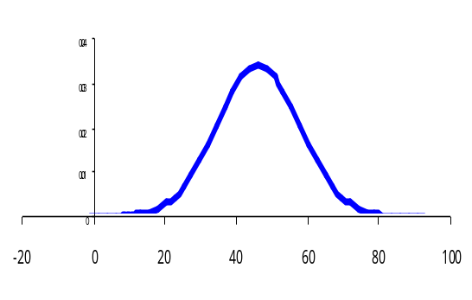
Mass Balance
In-Stream

Figure 10.2.1.4.1. Depiction of mass balance edge of field values being translated to match monitored edge of stream values.

10.2.4b Pasture EoS Nutrient Targets
Consistent with literature values (Beaulac and Reckhow, 1982, Alexander et al., 2001: other references) the pasture target loading rates for total nitrogen are set at 4.5 lb/ac-yr as a value of central tendency with a normal distribution of values which have a range of 0.1 lb/ac-yr to 27.5 lb/ac-yr. The range of values is determined by the estimated stocking rate for the pasture based on the estimated county segment area of pasture and the Agricultural Census estimate of pastured animals. The pasture target loading rates for total phosphorus is a median of 0.7 lb/ac-yr and as determined by the estimated stocking rates with a range of 0.1 lb/ac-yr to 4.4 lb/ac-yr is applied to reflect the different estimated manure loads from pastured animals.

10.2.5 Degraded Riparian Pasture EoS Nutrient Targets
The degraded riparian pasture land use represents unfenced riparian pasture with an associated stream degraded by livestock. This land use has high nutrient and sediment loads and is treated by riparian buffer BMPs. For each county segment the nutrient load target of nitrogen is set at 9.5 times the pasture target rate, and 12 times the pasture target rate for total phosphorus and suspended sediment. This factor is based on an analysis of time spent by beef and dairy livestock in riparian areas. Based on continuous video tapes of riparian and nonriparian pasture areas, the study found that pastured cattle spend about 9.5 times the time in riparian areas than they spend in nonriparian pasture [9/21/08 EMAIL ROB - Rob will provide the reference for this].

10.2.1.6 Nutrient Management Pasture EoS Nutrient Targets
Nutrient management pasture is pasture that’s included in a farm plan where crop nutrient management is practiced. Nutrient management pasture is pasture that receives excess manures on a farm after all crop nutrient needs are satisfied. Nutrient management pasture is land use originally calibrated as pasture and assumed to have the same estimated stacking rates as pasture, but has additional nutrient loads applied as nitrogen and phosphorus from manures in excess of crop land need are applied to this land use.

Nutrient management pasture loads are simulated by removing nutrient loads of manures or fertilizers consistent with the loading of pasture with a nutrient management plan.
9/21/08 ASK JEFF IF ABOVE IS TRUE

10.2.7 Hay-Unfertilized EoS Nutrient Targets

Hay unfertilized includes the land uses from the Agricultural Census of wild hay, idle cropland, and fallow land. These are considered to be in hay or in other ways an herbaceous agricultural area that does not receive fertilizer and are not harvested. Orchards are also included in this category.

The Phase 5 median target of exported nitrogen loads from hay unfertilized is set to 4 lb/ac-yr, a little more than twice that of the median load from forest, woodlots, and wooded areas. As this land is assumed to be infrequently planted or harvested the median target for the phosphorus exported load is set to 0.4 lb/ac-yr.

10.2.8 Hay-Fertilized EoS Nutrient Targets

Hay fertilized includes all tame and small grain hay excluding wild hay or alfalfa, which are included in other categories. These crops receive fertilizer and have a high degree of surface cover for most of the year. Failed cropland is also included in this category as failed cropland receive fertilizer but are not harvested, a pattern most similar to hay fertilized AGAIN, LAY DOWN ALL THE REFERENCES WE CAN HERE ON HAY LOADS

Since the hay fertilized land use receives fertilizer and has more extensive field operations of planting and harvest than the hay unfertilized land use, the nutrient loads exported are assumed to be higher. Accordingly, the hay-fertilized nitrogen export load target is set at 6 lb/ac-yr and the phosphorus load target to 0.8 lb/ac-yr.

10.2.9 Alfalfa EoS Nutrient Targets
This land use category contains only alfalfa hay. Alfalfa is simulated similar to hay except that alfalfa is leguminous. Accordingly, alfalfa fixes nitrogen at an estimated rate of xx lb/ac-yr CHECK WITH JEFF ON RATE USED (reference) which is added to the nutrients applied but at a rate of xx/day within the Phase 5 simulation during the growing season only. The target loads of alfalfa are slightly more than as hay fertilized for nitrogen, but are simulated with a different timing of application reflecting alfalfa nitrogen fixation. The nitrogen median export target load is 5.5 lb/ac-yr and the phosphorus median export target load is similar to hay fertilized at 0.7 lb/ac/year.

10.2.10 Conventional Tillage Cropland Receiving Manures EoS Nutrient Targets
The land use of conventional cropland receiving manures in Phase 5 has a specific operational definition and is a collection of land uses defined in the Agricultural Census. The conventional tillage cropland receiving manures land use includes grain, corn, soybeans, and dry beans. Wheat, corn, and soybeans are the dominant crops in the Chesapeake watershed, often planted in a two-year rotation on the same parcel of land. Crops in this land use receive nutrient inputs from manure application as well as fertilizer. This land use has conventional tillage operations in which less, often much less, that 35% cover remains on the ground at the time of planting.

Nutrient loads from cropland are highly variable reflecting a variable and dynamic agricultural industry. In addition, these loads are changing over time, as in the over two decade period (1985 to 2005) of the Phase 5 simulation, where different agricultural practices such as nutrient management are tested, take hold, and then become widely implemented. This is seen in the changing estimates of fertilizer and manures that are applied as estimated by the manure and fertilizer mass balances described in Section 5. Beaulac and Reckhow (1982) estimate the range of total nitrogen cropland load to be 3 to 80 kg/ha-yr with the 25% to 75% quartiles to be about 4 - 22 kg/ha-yr. Beaulac and Reckhow (1982) estimate the range of total phosphorus cropland load to be about 1 to 19 kg/ha-yr, with the 25% to 75% quartiles to be about 4 - 7 kg/ha-yr., which is consistent with the estimates of Langland et al. (1995) for cropland. Alexander et al. (2001) provides SPARROW estimates of total nitrogen loads ranging from 2.2 – 42.5 kg/ha-yr and literature values of cropland loads to be 0.8 – 79.6 kg/ha-yr. The median target of Phase 5 conventional cropland receiving manures is set at 23 lb/ac-yr. This is similar to the 23 lb/ac-yr used in the previous Phase 4.3 Model. The median phosphorus target is 2 lb/ac-yr, consistent with the range of literature values and the pervious Phase 4.3 calibration.

10.2.11 Conservation Cropland Receiving Manures EoS Nutrient Targets
The land use of conservation cropland receiving manures is similar to the conventional tillage cropland receiving manures land used but the tillage practice is changed in order to represent a cropland field operation that leave at least 35% cover at the time of planting

The median target of Phase 5 conservation cropland receiving manures is set at about XX lb/ac-yr. This land use has the same base flow dissolved nitrogen calibration target as conventional cropland receiving manures but this land use has 18% less surface runoff and loads of particulate and dissolved nitrogen (Simpson, 2007). The median phosphorus target is 30% less than conventional cropland receiving manures or 1.4 lb/ac-yr (ibid).

9/11/08 – MAKE CONSISTENT W? BELOW AS THIS IS FROM THE SECTION 6 UM BMP ANALYSIS:
- TN 8%, TP 22%, TSS 30%
If the WSM can separate surface and subsurface flow the TN performance will be modeled as 18% TN reduction in surface flow and 0% nitrate reduction in subsurface flow

10.2.12 Conventional Tillage Cropland Without Manures EoS Nutrient Targets
The conventional tillage cropland without manures land use in Phase 5 has a specific operational definition and is a collection of land uses defined in the Agricultural Census. The conventional cropland land uses include vegetables, tobacco, potatoes, peanuts, and cotton, all crops that don’t receive manure fertilizer and are usually crops for direct human or animal consumption. Though not receiving manure nutrients many of these crops such as vegetables and tobacco typically have high fertilizer inputs and extensive tillage operations. For these reasons the conventional tillage cropland without manures nitrogen expert target is set to 23 lb/ac-yr and the phosphors export target set to 2.5 lb/ac-yr.

Drop down bunches of references here.

10.2.13 Nutrient Management Hay, Pasture, Alfalfa, Conventional Tillage, Conventional Tillage Receiving Manures and Conservation Tillage Receiving Manures
This is a group of six nutrient management land uses that have all the same characteristics as their original land use except that the BMP of nutrient management is applied and this reduces their export accordingly. The nutrient management BMP requires a separate land use for every type of land use it’s applied to because it’s simulated as a reduction in fertilizer inputs, so nutrient uptake and export is different from the original land use at every time step of the simulation. The same calibration parameters are used as in the original land use, and the export targets are not set apriori but are calculated by the Phase 5 simulation. Nutrient management land uses usually have less nutrient export than the original land use as a consequence of the reduced input load.

10.2.14 Areas of Concentrated Manures EoS Nutrient Targets
Notes from 7/11/08 CHECK WITH JEFF: With the animals we have areas of animal feeding operations (AFOs) based on animal numbers in a county. The animal numbers are from the agricultural census and are the types of animals that one would find in a concentrated animal feeding area. This includes beef and dairy cattle, swine, and poultry. The different animal types have different loss rate from the animal feeding areas? Say with cattle at 10% and poultry at 1% because poultry is usually housed? Do we have beef cattle a smaller fraction of impact than dairy cattle because their usually on pasture?

The overall types of manure nutrient loads are simulated as three separate types of nutrient loss. The first is the loss from the AFO itself, the second is loss due to collection handling, and transport to either storage, agricultural lands for crop use, or off-farm transport, and the third loss is export over the growing season from cropland and pasture after application

The loss at the AFO is simulated to be …..

The loss from collection, handling and transport is simulated as….

The loss over the growing season after application to cropland and pasture is simulated in the separate cropland and pasture simulations.

10.2.15 Developed Land EoS Nutrient Targets
There are five classifications of developed land: low-intensity pervious, low-intensity impervious, high-intensity pervious, high-intensity impervious, and bare-construction.
The nutrient simulation of bare-construction land use is described in Section 10.2.1.18 and all other developed land is described in Section 10.2.1.15. Key nutrient inputs to developed land include atmospheric deposition to pervious and impervious developed lands, urban fertilizer to pervious developed land only, and miscellaneous nutrient inputs from wildlife, pets, and curbside urban refuse to both. In the Phase 5 simulation of developed lands a full mass balance approach is not used for all these inputs. Rather, the simulation of the magnitude of exported nutrient loads from developed lands is directly dependant on the volume of water discharged from high-intensity developed and low-intensity developed lands.

In the early stages of the Phase 5 Model development, when key land use decisions were being made, it was assumed that the NPDES Phase 1 storm water data would be a resource for determining load differences among developed land uses through characteristics such as development intensity, hence high- and low-intensity developed land uses were created for Phase 5. With the collection and analysis of the Phase 1 data little predictive ability for differences of water quality concentrations have been found among different Chesapeake watershed developed land uses as shown in Figures 10.2.16.1 and 10.2.16.2 (Pitt et al., 2004; Maestre and Pitt, 2005).

Figures 10.2.1.16.1 and 10.2.1.16.2 show the median concentrations of total nitrogen and total phosphorus for different land classifications and the number of observations in that classification. For the most part, the medians show remarkably little variability between land uses, especially when compared to the standard deviation.

Even though little differences have found in nutrient concentrations from different develop land uses it’s clear that the total load of nutrients from land uses with increased imperviousness have increased runoff, or discharge volume. The Phase 5 simulation uses this information to advantage through the fine resolution of imperviousness associated with each Phase 5 land-river-segment (Figure 4.4) as described below. For calculation of the developed land expected load, the overall median concentrations of 2.0 mg/l total nitrogen and 0.27 mg/l total phosphorus are used.

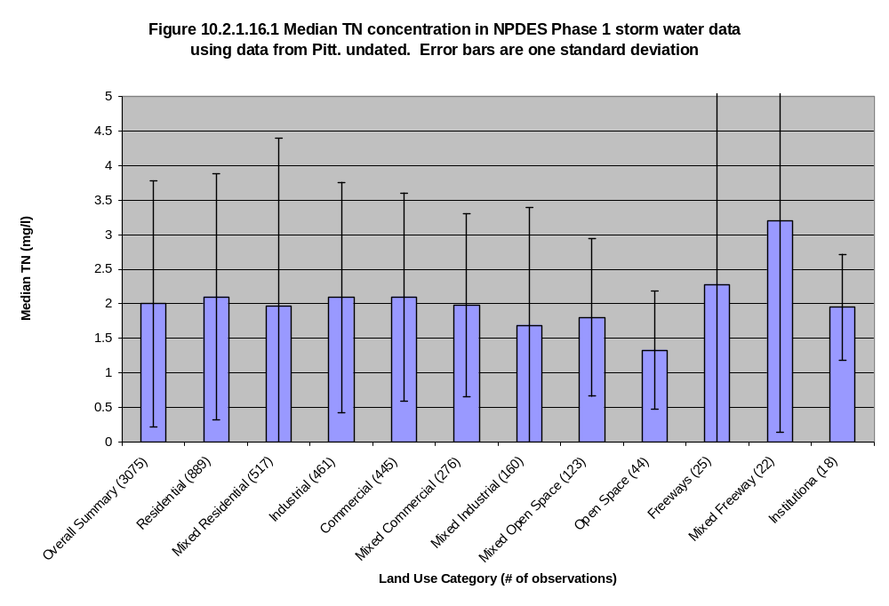

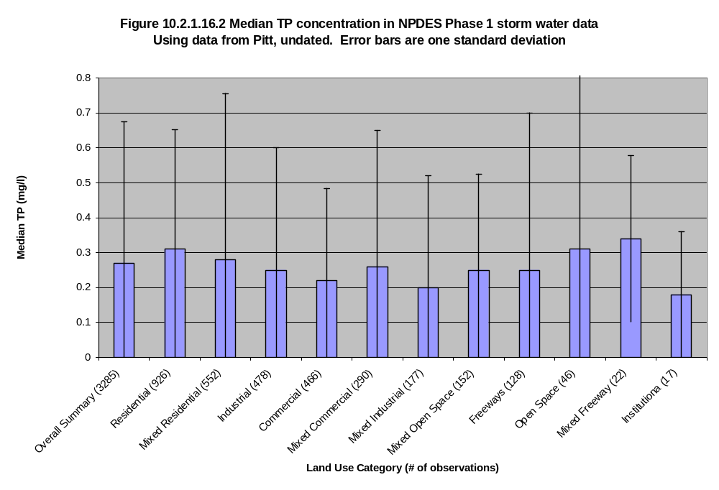

10.2.16 Low-Intensity Pervious, Low-Intensity Impervious, High Intensity Pervious, High Intensity Impervious Land EoS Nutrient Targets
A standard practice for estimating nutrient loads from developed land is the simple method, in which the annual nutrient load is determined by the annual runoff multiplied by the median event mean concentration (EMC) (Schueler, 1987; Pitt et al., 2004). The annual runoff is typically estimated from rainfall, detention storage, and the runoff coefficient, or in the case of the Phase 5 simulation, is directly simulated and the runoff estimates are taken directly from model output. We estimate the annual discharge of total surface and groundwater, from the Phase 5 model to represent the runoff, which is consistent with the Phase 1 observed data we use. Simply multiplying the annual discharge by the concentration gives an estimate of loading.

Although there’s a single total phosphorus concentration of 0.27 mg/l total phosphorus used for high-intensity and low- intensity pervious developed land, as well as for high-intensity and low-intensity impervious developed land, the annual discharge is unique for the calibration of developed land in every land-segment and so different land-segments have different total phosphorus loads depending on the precipitation to the land segment and the resultant estimated discharge. The simulation is further spatially refined by the use of imperviousness estimated on every land-river segment (Figure 4.4). A percent imperviousness is determined for both the high-intensity and low-intensity developed land use at the land-river-segment scale. The percent imperviousness provides an estimate of the mix of pervious and impervious area to be simulated on each Phase 5 land-river- segment for both the high-intensity and low-intensity developed land uses.

For example, if a land-river-segment was estimated to have 100 acres of low-intensity developed land and the percent imperviousness was 10% then 10 acres of impervious low- intensity developed land and 90 acres of pervious low-intensity developed land would be simulated. The same would be done for high-intensity developed land, though typically with estimates of higher imperviousness.

While the Phase 5 simulation does not distinguish between the nutrient loads of the high- intensity and low-intensity developed land uses, this is tracked as unique areas for each at the land-river-segments and reported as model outputs of loads from high-intensity and low-intensity developed land use. Typically the pervious and impervious land uses are combined to represent the total load from high- and low-intensity developed lands.

For total phosphorus the concentration is constant at 0.27 mg/l and is multiplied by the total outflow from pervious and impervious developed land gives a Phase 5 domain average of 1.1 lb/ac/year for pervious and 2.1 lb/ac/year for impervious developed land with a range of x.x to y.y for pervious and x.x to y.y for impervious developed land. For the two Phase 5 land uses of high- and low-intensity developed lands the Phase 5 domain average of z.z lb/ac/year for high-intensity developed and w.w lb/ac/year for low-intensity developed land with a range of x.x to y.y for high-intensity developed and x.x to y.y for low-intensity developed land.

For total nitrogen, the approach is similar but also takes into account the varying nitrogen loads from atmospheric deposition. For nitrogen loads from developed lands we track both atmospheric loading differences and discharge volume at the land-segment scale and also pervious-impervious differences at the land-river-segment scale as in the phosphorus simulation previously described.

When we simulate developed lands with PQUAL, we need to develop target for the major species of nitrogen, including nitrate, ammonia, and organic nitrogen. Maestre and Pitt (2005) found a relationship between percent impervious and NO₃+NO₂ concentration. with an intercept (completely pervious) of 0.756 and a slope of -0.009 mg/l per percent impervious. Following this estimate, one would calculate negative concentration for completely impervious urban land, which is an untenable outcome for the Phase 5 calibration approach A way to deal with this problem, and one that’s well within the range of error, is to assume that the concentration of NO₃+NO₂ is 0.8 for pervious land and 0 for impervious land. This is something of an extrapolation beyond the data, but since developed land loads by watershed are always a combination of pervious and impervious loads this method provides reasonable results that match the slope found by Maestre and Pitt.

No relationship between Total Kjeldahl Nitrogen (TKN) and land use was found so a constant value is used. Maintaining a weighted average concentration of 2.0 total nitrogen for all developed land and the above concentrations of NO₃+NO₂ gives a constant TKN of 1.4 mg/l, which is the median from Maestre and Pitt (2005) for all land use types. Multiplying by the runoff gives an average nitrogen load of 8.7 lbs/ac/year for pervious developed and 11.8 lb/ac/year for impervious developed for the overall Phase 5 domain average. Alexander et al. (2001) tabulates SPARROW estimates of urban, or developed, total nitrogen loads to be 3.6 to 175 kg/ha-yr and cites literature values of 1.6 to 38.5 kg/ha-yr.

The atmospheric loadings are estimated and the output from developed lands, especially impervious developed, can be expected to be related to the amount of atmospheric deposition it receives. The area-weighted atmospheric deposition of nitrogen on urban land is 13.7 lbs/ac-year. The targets for impervious land are calculated by dividing the deposition for each segment by the average and using that as a multiplier for the concentration. The same method is used for the pervious targets. The total nitrogen load input to pervious land is assumed to be only about half atmospheric deposition and the other half fertilizer and other sources (it would be nice to have a reference here), so the effect of the atmospheric deposition multiplier is halved.

For the pervious land use the Phase 5 domain average concentration for NO₃+NO₂ is 0.8 mg/l and 1.45 mg/l TKN but this average concentration is adjusted by the degree of atmospheric deposition on each land-segment. For the impervious land use the Phase 5 domain average TNK concentration is 1.45 ml/l only with no simulated nitrate loads as described above. For total nitrogen for both the pervious and impervious land uses the weighted average concentration is 2.0mg/l.

Using the total outflow from pervious and impervious developed land as described above gives a Phase 5 domain average of s.s lb/ac/year and t.t lb/ac/year for high- and low-intensity developed lands for the Phase 5 domain, with a range of x.x to y.y for high-intensity developed and x.x to y.y for low-intensity developed land (Figure 10.2.1.16.1).

Figure 10.2.1.16.1. GIS figure showing loads of high-intensity and low-intensity developed land uses at the land-river-segment scale.

10.2.17 Nursery EoS Nutrient Targets
In the Phase 5 simulation the nursery land use represents container nurseries which typically have a high density of plants (10-100 plants per square meter), and high rates of nutrient applications. Annual fertilizer application rates are in the range of 350 lbs to 1000 lbs or more of nitrogen per acre with equivalent application rates for phosphorus of 100-300 lbs/ac with use efficiencies in the neighborhood of 10-20%.

The container nurseries feature very high density of plants (10-100 plants per square meter are not uncommon), and have therefore very high rates of nutrient applications. While the plant density contributes much to these high rates, plant use efficiency is another big factor, with nutrient use efficiencies of the plants ranging from 10-30% (Lea-Cox and Ristvey, 2007). The phosphorus efficiencies are relatively lower than nitrogen efficiencies because these operations are using an organic growth medium that has little ability to trap anions such as phosphorus. Historically, it was not uncommon for growers to use 20-20-20 (Nitrogen-Phosphorus-Potassium) as an all-purpose fertilizer, meaning that the phosphorus export rates could be even higher, but it’s thought that this practice has abated somewhat.

Nutrients unused for plant growth or lost by denitrification, volatilization, or sorption are discharged. Many but not all operations have a collection system for the purposes of either detaining or re-using the greenhouse runoff. Systems that have only detainment may have significant denitrification, but phosphorus export may still be high. Re-use systems are less common than detainment, but they do exist, and at least in one example use a sophisticated collection and re-use system, where water was recycled through the system at least 5 times.

To simulate nurseries we assume nitrogen and phosphorus application rates of 600 lbs and 200 pounds respectively. We assume a 20% nitrogen and a 15% phosphorous utilization rate which removes by plant uptake 120 and 30 lbs respectively. We arbitrarily assume another 50% loss through volatilization, denitrification, or other losses through detainment or reuse systems. The final estimated target load for nurseries is 240 lb/ac-yr for nitrogen and 85 lb/ac-yr for phosphorus.

10.2.18 Bare-Construction EoS Nutrient Targets
Although construction and extractive land uses have very small acreages within the watershed, they are important because of their high sediment and nutrient loading. Nutrient inputs are from atmospheric deposition only, and nutrient export is of this atmospheric load, largely unattenuated, and of mass wasting of the soil. In construction sites, large amounts of loose, disturbed soil is easily eroded as discussed in Section 9 resulting in high export loads of sediment and nutrients, particularly phosphorus. The average mass balance diagrams for the bare-construction land use is shown in Figure 10.2.X.

There is little literature available regarding nutrient export rates from construction sites. Line et al. (2002) reports TOTAL NITROGEN and TOTAL PHOSPHORUS export rates of 7.4 and 2.6 lb/ac-yr respectively for the clearing and grading phase of residential construction, and 32.2 and 1.2 lb/ac-yr during house, road, and storm drain construction. Daniel et al. (1979) reports values ranging from 12.2 to 49.5 lb/ac-yr for total nitrogen and 6.7 to 17.9 lb/ac-yr for total phosphorus. For Phase 5 we’ve chosen the target values of 25 lb/ac-yr for total nitrogen and 7 lb/ac-yr for phosphorus. These target loads are what’s estimated to be exported from the bare-construction land use without BMP controls and the nutrient loads are decreased with the application of erosion and sediment control BMPs as described in Section X.X.

10.2.19 Extractive Land Use EoS Nutrient Targets
There is little literature available regarding nutrient export rates from active and abandoned mine sites. Brabets (1984) reports similar nutrient loading from the land areas as the reference sited above for the bare-construction land use. To represent the nutrient exports from the extractive land use, we’ve chosen to take the values of ½ that of the bare-construction estimated nutrient export rates. The extractive land use has nutrient targets estimated to be 21.5 and 3.5 lb/ac-yr for total nitrogen and total phosphorus respectively.

10.2.20 Water Surfaces
Water surfaces also have a nutrient input loads from deposition. The nitrogen loads is assumed to be entirely from atmospheric deposition. The daily wet and dry deposition of dissolved inorganic nitrogen is obtained from regression and air quality models as described in Section 5 and organic nitrogen disposition loads are described below.

The same estimated atmospheric organic nitrogen loads are used in both the watershed and tributary models. Both models load atmospheric organic nitrogen to only water surfaces on the assumption that all organic nitrogen is derived from aeolian processes which result in no net change in organic nitrogen on terrestrial surfaces but result in a net gain to water surfaces. Organic nitrogen is represented as wet fall only or dissolved organic nitrogen (DON). The magnitude of dry fall organic nitrogen is unknown.

In the 1992 versions of the watershed and tributary models, organic nitrogen is assumed to be about 670 ug/l (as N) based on data summarized by Smullen et al. (1982). The data showed considerable seasonal variability. The organic nitrogen load was constant in all watershed model segments. An equivalent annual load was used in the tributary model with application of the seasonal variability suggested by Smullen.

Organic nitrogen measurements from Bermuda are calculated at about 100 ug/l (as N) (Knap et al., 1986) (Knap, Jickells et al. 1986). Moper and Zika reported an average DON concentration from the western Atlantic and Gulf of Mexico of about 100 ug/l (as N). This is consistent with the reported range from the North Sea and northeast Atlantic of between 90 ug/l to 120 ug/l (Scudlark and Church 1993). A recent study reports an annual volume weighted average DON concentration in the mid-Atlantic coastal areas to be about 130 ug/l (as N) (Scudlark, Russel et al. 1996). Measurements in this study are consistent with the interannual variation (maximum in spring) reported by Smullen.

In the Phase 5 model we use 130 ug/l (as N) as representative of an average annual wet deposition concentration to the watershed and tidal waters with the seasonal loading pattern suggested by Smullen (1982) and Scudlark et al.(1996). This will apply an average concentration of 98 ug/l from July to March rainfall and an average concentration of 224 ug/l from April to June. On average this is a annual load of organic nitrogen of xx lb/ac-yr. Organic nitrogen deposition, which includes pollen, amino acids and other relatively biologically available material is arbitrarily considered to be 30% labile organic nitrogen with the remaining portion refractory.

FIND THE REFERENCE WE HAD FOR PHOSPHORUS TO WATER SURFACES & INSERT HERE

The overall estimated nutrient export loads are given in Table 10.3.1

Table 10.3.1. Nutrient export loads used for average calibration targets.
Land Use | Median TN Load  (lb/ac-yr) | Median TP Load  (lb/ac-yr)
conventional crop receiving manures | 23 | 2.0
conventional crop without manures | 23 | 2.5
conservation crop receiving manures | XX | 1.4
alfalfa | 5.5 | 0.7
hay fertilized | 6.0 | 0.8
hay unfertilized | 4.0 | 0.4
degraded riparian pasture | pasture * 9.5 | pasture * 9.5
pasture | 4.5 | 0.7
areas of concentrated manures
pervious developed | 8.7 | 1.1
impervious developed | 11.8 | 2.1
nurseries | 240 | 85
bare-construction | 25 | 7.0
extractive | 21.5 | 3.5
forest, woodlots, and wooded areas | 2.0 | 0.10
harvested forests | 20.0 | 0.80
water surfaces – nontidal | * | *
water surfaces – tidal | * | *

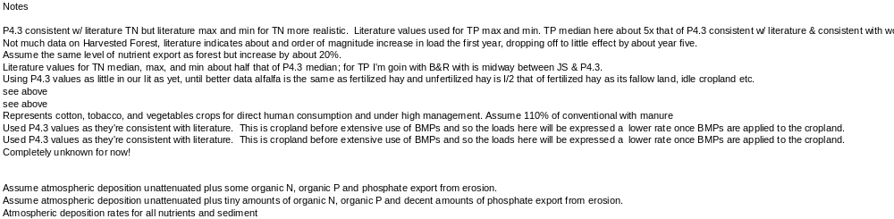* 9/10/08 Get the average tidal and nontidal nitrogen deposition load to water surface. Check on the incorporation of organic nitrogen in the loads for the P5 & WQSTM. Get write-up on the phosphorus loads to water surfaces & make sure this is also in the P5 & WQSTM

10.3 Nutrient Calibration Decision Rules
The nutrient calibration was carried out separately for each land use in all land-segments. Since there are a large number of target loads to be reached, a manual calibration of nutrient export would be difficult. As a result, an Automatic Iterative Method (AIM) was developed to carry out the land use nutrient calibration. The AIM iteratively adjusts model parameters based on a set of decision rules, which relate the sensitivity of model parameters to particular model outputs in attempting to match edge-of-stream loadings and county-level crop yield data. Calibration starts from the parameter set from manual calibration and the procedure is controlled and implemented by a group of computer programs.

The AIM is superior to a conventional trial-and-error approach in several aspects. The calibration procedure is operated entirely automatically, offering the kind of efficiency required for a feasible calibration of the Phase 5 model. The calibration methodology has clear rules and objectives, thus eliminating the potential subjective nature of individual model practitioners performing a calibration. The AIM ensures an equitable treatment of all land uses across the Phase 5 domain. Moreover, the procedure is repeatable, allowing an efficient model recalibration whenever new data is available and an update is needed.

Depending on the land uses, the Phase 5 model utilizes either the HSPF AGCHEM or PQUAL modules to simulate land nutrient processes. The AGCHEM module is a complete mass balance of nutrients and includes features like plant uptake and soil transformation of nutrient species (Bicknell et al. 2001). The PQUAL module is a supplier approach which simply associates a nutrient concentration with the load of sediment exported from a land use.

The AGCHEM module is applied to major land uses with nutrient application such as cropland and other agricultural land uses, while the PQUAL module is used for land uses either receiving only atmospheric deposition, or intensive animal waste where a detailed mass-balance approach would be difficult to apply such as in the land use of animal feeding operations. Consequently, different decision rules are developed for different land uses, for both nitrogen and phosphorus, based on the module used. Within the AGCHEM module, the decision rules are further differentiated by the plant uptake methods and availability of field uptake data.

10.3.1 AGCHEM Nitrogen Calibration Rules
Nine land uses are simulated using the AGCHEM module, including three types of cropland, alfalfa, hay, pasture, two types of pervious urban and wooded land. For each of these land uses, eight calibration targets are specified for nitrogen calibration, including NO₃, NH₃, labile organic nitrogen, and refractory organic nitrogen for both groundwater and surface layers (Figure 10.3.1). The calibration targets are the estimated average annual nutrient loads for these land uses, and all of the 1985 to 2005 simulation years were used to form the Phase 5 annual average which was compared to the calibration targets.

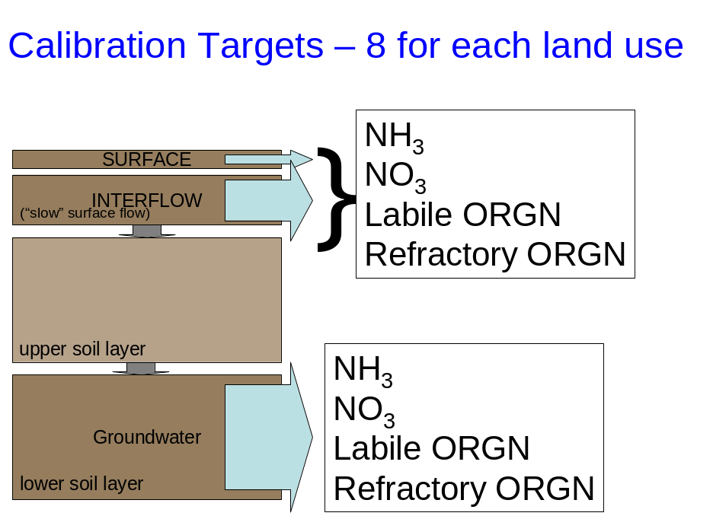

Figure 10.3.1. Eight calibration targets of nutrient species in both surface and base flow.

The nitrogen calibration objective is to reach each of the eight average annual target loads by adjusting relevant parameters. Nitrogen is simulated in the AGCHEM module in detailed soil processes, which involves about 100 parameters in four soil layers. Among them, however, eight are particularly sensitive and used for the calibration:
- KAM - organic N ammonification
- KDNI - denitrification rate of NO₃
- KNI - nitrification rate
- KIMAM - rate of return of ammonium to organic nitrogen
- KIMMI - rate of return of nitrate to organic nitrogen
- KLON - particulate/soluble partitioning coefficient for labile organic N
- KRON - particulate/soluble partitioning coefficient for refractory organic N
- WILTP - wilting point in yield-based uptake method
The KIMMI and KIMAM variables are unusual as they unrepresentative of actual nutrient transformation pathways , but are a way to represent the uptake of nitrate or ammonia by other plants in cropland such as weeds, or by soil bacteria and are a separate pathway to return inorganic nitrogen to organic nitrogen other than that of the simulated crop.

Each one of the above parameters requires four values, one for each soil layer. The parameters in first two soil layers, surface flow and interflow, affect surface loading and the parameters in the third and fourth layers, consisting mainly of groundwater, affect subsurface loading.

The agricultural lands of conventional tillage cropland without manures, conservation cropland receiving manures, conventional cropland receiving manures, alfalfa, and hay-fertilized are all simulated using a yield-based uptake method based on the Agricultural Census crop yield data. For these land uses, four decision rules are developed to regulate parameters to meet nitrogen targets as well as match crop yield data:
- KAM is adjusted to balance organic nitrogen and inorganic nitrogen
- KNI and KDNI (below surface only) are used to reach NH₄ and NO₃ targets
- KLON/KRON is used to reach organic nitrogen targets
- KIMAM/KIMNI and WILTP are used to reach uptake data

A graphic of the calibrated conservation cropland receiving manures land use is shown in Figure 10.3.2. All of the land-segments are displayed on the x-axis and are identified with a number designate, and the simulated annual export load is displayed in units of pound/acre-year on the y-axis. In this case the total nitrogen target is a little over 20 pounds/acre-year and varies due to the relative amounts of fertilizer and manure loads and crop yields as described in Section 5. Most of this is in the form of nitrate, particularly subsurface nitrate.

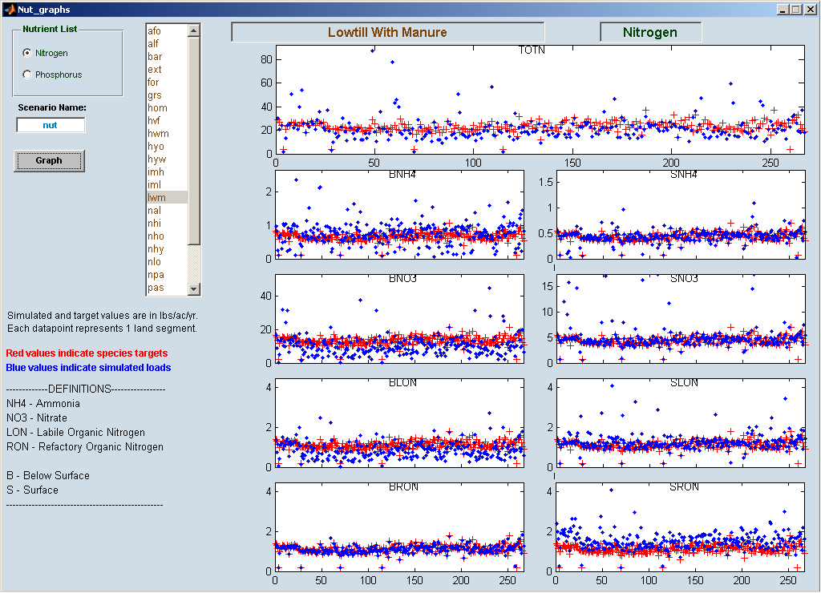

Figure 10.3.2. A plot of the conservation cropland receiving manures calibration with all of the land-segments are displayed on the x-axis with a number designate, and the simulated annual export load is displayed in units of pound/acre-year on the y-axis. TOTN = total nitrogen, BNH4 = subsurface ammonia, SNH4 = surface ammonia, BNO3 = subsurface nitrate, BLON =subsurface labile organic nitrogen, SLON = surface labile organic nitrogen, BRON = subsurface refractory organic nitrogen. SRON = surface refractory organic nitrogen.

Pasture is handled differently from the above land uses in two aspects. The plant uptake in pasture is simulated by a first-order method in HSPF. Consequently, wilting points are not applicable and only NH₄/NO₃ immobilization rate are adjusted to reach available uptake data. Also, the ammonia volatilization rate is optimized for pasture instead of remaining static as in other land uses, in order to get rid of NH₄ when surface DIN are 20% higher than targets.

The AGCHEM module does not reset the plant N storage every year to reflect plant harvest. To represent this in Phase 5, the daily first order return rate of plant biomass to soil organic nitrogen is set relatively high at about 0.02 after the crop harvest. This returns all of the plant biomass to the soil by the next planting season. Of the returned plant nitrogen 40% is returned to the soil as refractory organic nitrogen each year and the rest is returned as labile organic nitrogen. One effect this has is to increase slightly the refractory organic nitrogen export over time, but this is increase is small, on the order of about 5% and the overall approach is considered to be the best approach to achieving continuous simulations of soil nutrients given HSPF limitations.

Nitrogen calibration for the forest, woodlots, and wooded land use is focused on reaching EoS targets and also maintaining a stable storage over time. The model parameters are adjusted with the same decision rules as used for croplands. In a similar fashion to the cropland simulation KIMMI and KIMAM are used to reach forest nitrogen uptake targets, which is estimated to be 60 lbs/ac/yr (Hunsacker et. al, 1993).

Maintaining a stable storage is the key to ensure a reasonable simulation of forest nitrogen cycle, and is done by resetting the initial storage to the average storage of the last three year’s simulation after each iteration of the AIM calibration. The reset ensures the initial storages are compatible with adjusted parameter values so that N storage in soil and trees won’t be depleted over time. Figure 10.3.3. shows the results of the forest, woodlots, and wooded simulation for all the Phase 5 land-segments.

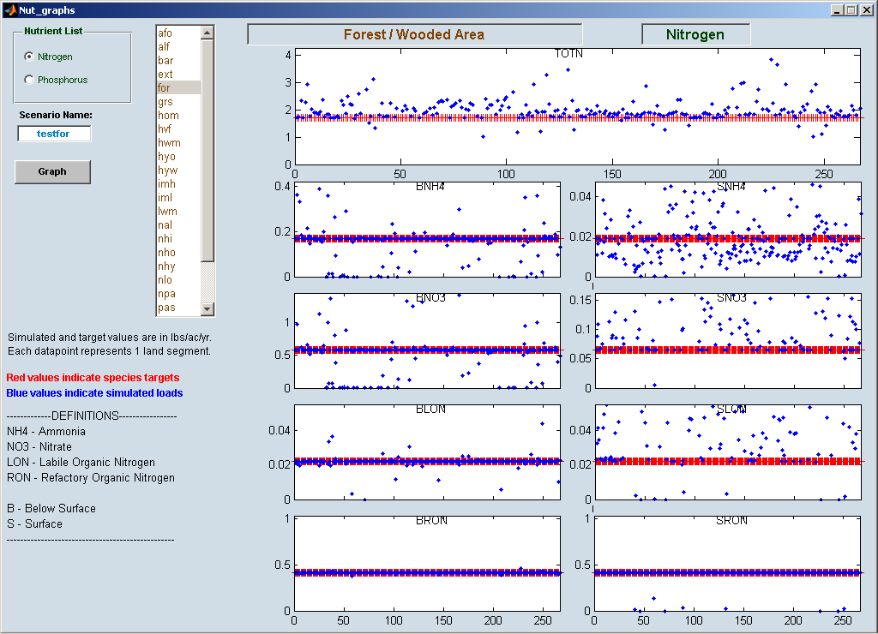

Figure 10.3.1 Estimated Nutrient Balance for Forest, Woodlots and Wooded Areas

Figure 10.3.3. Results of the forest, woodlots, and wooded simulation for all the Phase 5 land-segments. TOTN = total nitrogen, BNH4 = subsurface ammonia, SNH4 = surface ammonia, BNO3 = subsurface nitrate, BLON =subsurface labile organic nitrogen, SLON = surface labile organic nitrogen, BRON = subsurface refractory organic nitrogen. SRON = surface refractory organic nitrogen.

The calibration for the high- and low-intensity developed pervious land uses and hay-unfertilized land use is done the same way as for the cropland for the most part, except that the KIMAM is used to reach a balance between organic N and inorganic N rather than matching uptake data as for croplands, because there is no plant uptake data available for these land uses.

The initial storages for labile and refractory organic nitrogen are optimized as well. The optimization is done by increasing or decreasing the initial storages so that the total storages of the first three years won’t exceed the percent of three years accounting for the entire simulation period. This approach is applied to all above land uses with the exception of forest. This intends to eliminate, for example, large spikes in the data for the first year due to a high initial storage, and stabilizes the storage of nutrients over time.

10.3.2 AGCHEM Phosphorus Calibration Rules
Phosphorus calibration is relatively straightforward because the simulated phosphorus cycle in HSPF’s AGCHEM is less complex (Bicknell et al. 2001). The AGCHEM phosphorus simulation is focused on the fate and transformation of PO₄, while the simulation of organic P is largely left to a ratio of the simulated organic N. A Redfield stoichiometric ratio of 16:1 nitrogen to phosphorus is used.

The objective of the AGCHEM phosphorus calibration is to match PO₄ targets for both surface and groundwater. Three parameters are sensitive in the phosphorus simulation and are used for the calibration. As with the nitrogen simulation, each parameter requires four values, one for each soil layer.
- KIMP - rate of return of phosphate to organic phosphorus
- KMP - organic P mineralization rate
- K1 - coefficient for the Freundlich adsorption/desorption equation
The KIMP variable is like the KIMMI and KIMAM variables and represents the uptake of phosphate by other plants in the cropland land use such as weeds, or by soil bacteria and are a separate pathway to return in phosphate to organic phosphorus other than that of the simulated crop.

Crop yield data are available for the land uses of agricultural lands of conventional tillage cropland without manures, conservation cropland receiving manures, conventional cropland receiving manures, alfalfa, and hay-fertilized (Jing you also had pasture in this list but I don’t think that’s right), and the phosphorus uptake is simulated by a first-order method. For these land uses, three decision rules are developed to calibrate parameters to meet the phosphate targets as well as match crop yield data:
- Adjust KIMP to control transformation of PO₄
- Adjust KMP to reach uptake targets
- Adjust K1 to reach PO4 targets

There is no uptake data available for hay-fertilized, so all three parameters were adjusted to reach PO4 targets for this particular land use.

The initial storages are not optimized in the phosphorus calibration and stay at the pre-specified values throughout the optimization process. Jing what does this mean?

10.3.3 PQUAL Calibration Rules
PQUAL is used to simulate nitrogen and phosphorus loads for land uses of bare-construction, extractive, harvested forest, degraded riparian pasture, animal feeding operations, nursery, low-intensity impervious, and high intensity impervious. These land uses generally have relatively smaller acreages, and is assumed to receive only atmospheric deposition inputs, or in the case of animal feeding operations, only extremely high levels of manure inputs.

The decision rules for PQUAL: (GARY, PLEASE ADD YOUR METHODS HERE)

For wooded and urban land uses, PQUAL is used for the phosphorus simulation
For the forest, woodlots, and wooded land use, there is no manure or fertilizer source of phosphorus. The source of phosphorus in simulated woodland soil is assumed to be produced by natural weathering processes. If the AGCHEM simulation, which is based on mass balance, was used it would only be able to produce reasonable phosphorus export by using a large initial storage of organic phosphorus as a stand-in for the natural weathering processes. The drawbacks in this approach are that the generation of phosphorus in the soil would be temperature dependent and the export of phosphorus would decrease over time as the soil storage was depleted. To avoid these problems, the PQUAL simulation, which appropriately enough is sensitive to hydrologic and sediment processes only, was used

In the case of the high- and low-intensity developed pervious land uses, the phosphorus that is attributed to the land is thought to be primarily produced by scour of small streams downstream of the urban areas. Again in this case, attempting a mass balance on the land simulation would be inappropriate. Since the mechanism of phosphorus production is scouring, the sensitivities to hydrologic processes in the PQUAL simulation are appropriate.

10. 4 Assessment of the Nutrient Calibration
As with the decision rules, the measurements used to assess the nutrient calibration also vary by land uses, depending on the modules by which they are simulated. For the land uses simulated with PQUAL, the only measurement used is the comparison of modeled exports to EoS targets, due to the simple mechanism of the module. PQUAL calibration can achieve exact EoS targets with the first run, so further discussion on its assessment is unnecessary. For the land uses simulated using AGCHEM, the assessment of nutrient calibration involves five key calibration decision rules concerning different aspects of a mass-balance simulation:
- Modeled TN, TP loads within 25% of targets
- Model exports of nutrients sensitive to climate variations and agricultural practices to annual targets.
- Nutrient storage in soil profile remain stable over long term
4. Model parameters within a reasonable range and in a fairly constrained distribution
5. Model simulated plant uptake within the reasonable range of field data (if available)

    - Land Use Calibration to EoS Nutrient Targets
The assessment of the land use calibration to EoS targets is focused primarily on the TN and TP targets, because these loads are the ones used to develop management policies. Also the splits between nutrient spices other than TN and TP are less well defined in the literature. The simulation of TN and TP loads within 25% of targets is widely accepted as a good calibration, according to the HSPF criteria for annual value (A.S. Donigian, Jr. et al. 1984), and is used as a quantitative measurement of model performance. Figure 10.4.1.1 and Figure 10.4.1.2 show the percent of land-segments that reached TN and TP targets for each land use. Overall, more than xx% (Jing to provide this) of segments reached the TN and TP targets. The simulated loads of each nutrient species are also assessed and the quantitative assessment of how well the different nutrient species do in matching the average annual targets is available with this <HOTLINK>

Figure 10.4.1.1. Percent of land-segments that reached TN targets for each land use. (Jing to provide this)

Figure 10.4.1.2. Percent of land-segments that reached TP targets for each land use. (Jing to provide this)

    - Simulation of Plant Nutrient Uptake to Match Estimated Crop Yield Data
An accurate simulation of plant nutrient uptake provides the basis of a sound nutrient calibration. The fate of the majority of the atmospheric, manure, and fertilizer nutrients applied to crop land is to be primarily to be taken up by the crop. Simulated crop uptake is calibrated to be consistent with Agricultural Census county-based estimates of crop yield. Estimated crop yield data are available for the six agricultural land uses of need list of land uses here. Plots of the simulated plant uptake verses estimated crop yield data for each of the six land uses is shown in figures Figure 10.4.2.1 – Figure 10.4.2.6.

Figure 10.4.2.1. Simulated and estimated plant uptake fro land use 1. (Jing to provide this)

Figure 10.4.2.2. Simulated and estimated plant uptake fro land use 2. (Jing to provide this)

Figure 10.4.2.3. Simulated and estimated plant uptake fro land use 3. (Jing to provide this)

Figure 10.4.2.4. Simulated and estimated plant uptake fro land use 4. (Jing to provide this)

Figure 10.4.2.5. Simulated and estimated plant uptake fro land use 5. (Jing to provide this)

Figure 10.4.2.6. Simulated and estimated plant uptake fro land use 6. (Jing to provide this)

    - Response to Nutrient Management Actions
The calibrated model will be used to develop management scenarios, so it is vital that the model responses reasonably to climate variations and agricultural practices. The sensitivity of model response is tested by comparing model results of regular crop with nutrient management crop. The calibrated land parameters were used to run the counterpart of nutrient management land with reduced nutrient input. The model’s capacity of simulating management actions is reflected at reduced nutrient export in TN and TP, as shown in Figure 10.4.3.1 and Figure 10.4.3.2 for different agricultural land uses. Q: Keep this here or put this as a special case of the mass balance graphics in Section 10.4.6?

    - Stable Storage Over Time
Nutrient storage in the soil profile should remain stable over the simulation period, particularly for the forest, woodlots, and wooded land use and crop land uses which have a large pool of soil organic nitrogen. Given the large numbers of land segments in the watershed, it is difficult to show this aspect of model calibration in a concise way. As a result, the change of organic nitrogen storage over time for forest, woodlots, and wooded land in XX county, (land-segment XX) is shown here as a representative example (Figure 10.4.4.1). The nitrogen storages for the other land–segments counties have a similar pattern and remain stable over the 1985 to 2005 simulation period.

Figure 10.4.4.1. The change of organic nitrogen storage over time for forest, woodlots, and wooded land in XX county. (Jing to produce this plot)

10.4.5 Constrained Distribution of Model Parameters
The range of the calibrated model parameters were also evaluated, in order to make sure their values are within a reasonable range and constrained distribution. Figures 10.4.5.1 and 10.4.5.2 show percentile of calibrated parameters on a log scale.

Figure 10.4.5.1. Percentile of calibrated parameters on a log scale. (Jing to provide this)

Figure 10.4.5.2. Percentile of calibrated parameters on a log scale . (Jing to provide this)

10.4.6 Quality of the Land Use Calibration to Literature Target
Use this section to present the hot links to all the calibration information of the different land uses. Also use this section to describe the different mass balances as we did in the Phase 4.3 Decision Rules document. (Jing to produce the mass balance graphics based on Phase 5.2 calibration.)

10.5 Regional Nutrient Transport Factors
The Phase 5 simulation relies on county level assessments of land use and animal numbers. This sets key model inputs, such as the land use and the manure and fertilizer inputs, at the county scale, which corresponds to about 300 different spatial units over the Phase 5 Model domain. Many of these key inputs for agricultural land uses are based on an analysis of the available manure, fertilizer, and atmospheric deposition inputs and the record of crop production, and hence nutrient uptake, in the county level data. The riverine simulation is at a finer scale, and has more than a thousand spatial riverine segments. In order to deal with the uncertainties in distributing county level data down to the smaller river-segment units, as well as for adjusting for any geographic differences in nutrient fate and transport, regional nutrient transport factors are used.

The application of regional nutrient transport factors is needed because of uncertainties in inputs. For example, the fertilizer application data for a particular land-segment are based on best professional judgment and only related to fertilizer sales at the scale of the entire model domain. Finer-scale data in unavailable due to the unknown factor of the degree of fertilizer transportation between the sites of sale and application. There’s also uncertainty in agricultural practices at spatial scales less than the county level. In addition regional geomorphic characteristics such as soil qualities and slopes can have a large effect on exports. Other influences include the spatial range of average rainfall of between 37 inches and 56 inches per year. This difference can create a large difference in exports particularly on windward and leeward sides of mountains. Finally, the export to a 100 cfs or greater simulated river is dependent on the characteristics of the local stream network that may contribute or decrease nutrients

The regional nutrient transport factors are used in calibrating the river simulation to local observed data and it becomes necessary to adjust the local export values to meet water quality concentrations in the stream. The regional nutrient transport factors are determined by riverine calibration. The loads from the calibrated land uses are run in the riverine simulation using the Phase 5 decision- rules and compared to the observed loads from the more than 100 calibration stations for nutrients. The automated iterative method of calibration for the river at the conclusion of the calibration run examines the difference between the simulated and the observed load an provides a separate TN and TP regional nutrient factor that’s applied only to the nonpoint source loads specifically associated with that monitoring station. The regional factor may be positive or negative and is separate for both TN and TP, because each has separate processes that effect their fate and transport. Typically two to six iterations of calibration are used to set the final regional nutrient factors.

The process of setting the regional transport factor is done from the top down in the river network. That is, the headwater segments are first examined for each group of segments associated with the first major downstream gage. For this group of segments the regional nutrient factor is set as described above. Then the next major downstream gage and associated model segments are examined. With the segments above the first gage already with a set regional nutrient factor, the regional factor is applied to only to the nonpoint source loads in the segment controlled by the second gage. This process is then repeated until the regional nutrient factors are set in the entire riverine portion of the watershed. The estimated regional transport factors for TN and TP are shown in Figures 10.4.1 and 10.4.2. (Gary – need your help in making these figures). The major monitoring stations used to set the regional nutrient factors are: LIST THEM ALL HERE

We’ll find out where the major stations are that we apply the regional factors at the week of August 4, 2008. There has been a lot of concern about the ‘unexplainable large spatial variability’ or ‘popcorn-ness’ of the regional factors. In discussions with Ross and Bills B&K, we’ve decided that we will only do the adjustment at selected sites. Probably Towanda, Danville, Lewisburg, Newport, and Conowingo in the Susquehanna and similarly sized stations in the Potomac. Only the fall line for Rapp, and only the ‘good’ station in the James for TP.

For the regions close to tidal waters, such as the Coastal Plain and the Western Shore, and unassociated with river-segments another approach was used. Few of the segments in the Coastal Plain and Western Shore are monitored but for the few that are the regional transport factors can be calculated. An assessment showed that the coastal plain segments had a different regional transport factor which was generally less in both TN and TP than the Western Shore (Table 10.4.1) (Gary need your help in putting together this table). The relatively low regional transport factors for the Coastal Plain are consistent with the low gradients, relatively high water tables, and high potential for denitrification as described in the literature (USGS reference here, add others).

10.6 Nutrient Budgets
Use the examples of the Phase 4.5 Calibration Rules document for this section.

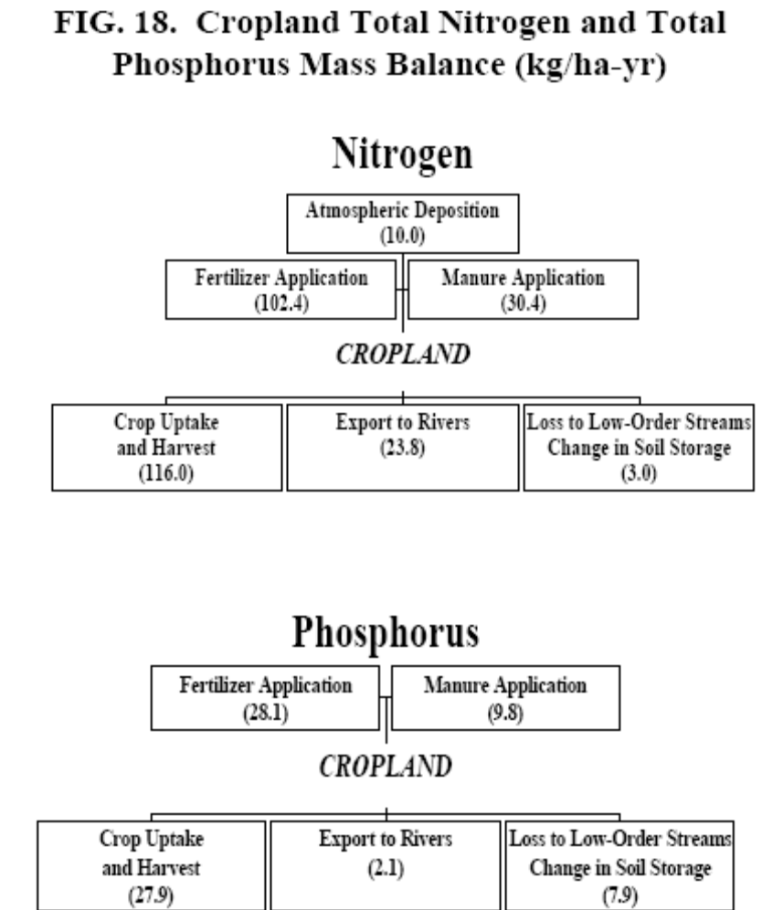

References
Aber, J.D., K.J. Nadelhoffer, P. Steudler, and J.M. Melillo. 1989. Nitrogen saturation in northern forest ecosystems Bioscience 39:6 pp: 378-386.

Aber, J.D., C.L. Goodale, S.V. Ollinger, M.L. Smith, A.H. Magill, M.E. Martin, R.A. Hallett, and J.L. Stoddard. 2003. Is nitrogen deposition altering the nitrogen status of northern forests? Bioscience, v. 53, no. 4, p. 375-389.

Alexander, R.B., R.A. Smith, G.E. Schwarz, S.D. Preston, J.W. Brakebill, R. Srinivasan and P.A. Pacheco. 2001. Atmospheric nitrogen flux from the watersheds of major estuaries of the Unites States: An application of the SPARROW watershed model. In Nitrogen Loading in Coastal Water Bodies: An Atmospheric Perspective. Published by the American Geophysical Union pp119-170.

Arthur, M.A.; G.B. Coltharp, and D.L. Brown. 1998. Effects of best management practices on forest streamwater quality in Eastern Kentucky Journal of the American Water Resources Association 34:3 pp:481-495.

Brabets, T.P. 1984. Runoff and Water Quality Characteristics of Surface Mined Lands in Illinois. Geological Survey Water-Resources Investigations Report 83-4265.

Beaulac, M.N. and K.W. Reckhow. 1982. An examination of land use - nutrient export relationships. Water Resources Bulletin 16:6, pp1013-1022.

Bicknell, B.R., J.C. Imhoff, J.L. Kittle, Jr., T.H. Jobes, and A.S. Donigian, Jr. 2001. Hydrologic Simulation Program—Fortran. HSPF Version 12 Users Manual. U.S. Environmental Protection Agency, Office of Research and Development, Athens, GA, and U.S. Geological Survey, Hydrologic Analysis Software Support Program, Reston, VA
Campbell, K.L. 1982. Nutrient transport from North Florida agricultural fields and watersheds. Ed. Baldwin, L. B.; Bottcher, A. B. IFAS Conference on Nonpoint Pollution Control Technology, Gainsville, Florida March 9-10, 1982.

Castro, M. S.; K.N. Eshleman, R.P. Morgan II, S.W. Seagle, R.H. Gardner, and L.F. Pitelka. 1997. Nitrogen dynamics in forested watersheds of the Chesapeake Bay. STAC Report Number: 97-3 Scientific and Technical Advisory Committee, Frostburg, MD, June 1997.

Clark, Gregory M., D.K. Mueller, M.A Mast. 2000. Nutrient concentrations and yields in undeveloped stream basins of the United States Journal of the American Water Resources Association 36:4 pp: 849-860.

Daniel, T.C., P.E. McGuire, D. Stoffel, and B. Miller. 1979. Sediment and nutrient yield from residential construction sites. Journal of Environmental Quality 8(3):304-308.

Donigian, Jr., A.S., J.C. Imhoff, B.R. Bicknell, J.L. Kittle, Jr. 1984. Application Guide for Hydrological Simulation Program – Fortran (HSPF). U.S. Environmental Protection Agency, Environmental Research Laboratory, Office of Research and Development, Athens, GA.

Ensign, S.H., and M.A. Mallin. 2001. Stream water quality changes following timber harvest in a coastal plain swamp forest. Water Research 35:3381-3390.

Frick, E.A., and G.R. Buell. 1999. Relation of land use to nutrient and suspended sediment concentrations, loads, and yields in the upper Chattahoochee River basin, Georgia, 1993-98. Ed: Hatcher, Kathryn J. 1999 Georgia Water Resources Conference University of Georgia Athens, GA.

Goodale, C.L.; K. Lajtha, K.J. Nadelhoffer, E.W. Boyer, and N.A. Jaworski. 2002. Forest nitrogen sinks in large eastern U.S. watersheds: Estimates from forest inventory and an ecosystem model. Biogeochemistry 57:58 pp:239-266.

Hunsacker, C.T., C.T. Garten, and P.J. Mulholland. 1993. Nitrogen outputs from forested watershed in the Chesapeake Bay Drainage Basin. Environmental Sciences Division, Oak Ridge National Laboratory, Oak Ridge, TN.

Knap, A., T. Jickells, et al. 1986. “Significance of atmospheric-derived fixed nitrogen on productivity of the Sargasso Sea.” Nature 320(March 13): 158-160.

Langland, M.J., P.I. Lietman, and S. Hoffman. 1995. Synthesis of Nutrient and Sediment Data for Watersheds within the Chesapeake Bay Drainage Basin: USGS in cooperation with EPA Water Resources Investigations Report 95-4233. Lemoyne, PA.

Lea-Cox, J., and A. Ristvey. 2007. Personal communication between Robert Burgholzer and Drs. John Lea-Cox and Andrew Ristvey during a Mach 23, 2007 meeting on University of Maryland College Park research and outreach with the nursery industry in Maryland.

Lobo, M.E. and R.B. Herrmann. 1998. Harvest impacts on forest outflow in coastal North Carolina Journal of Environmental Quality 27:1382-1395.

Line, D.E., N.M. White, D.L. Osmond, Gregory D. Jennings, and C.B. Mojonnier. 2002. Pollutant export from various and uses in the Upper Neuse River Basin. Water Environment Research 74(1):100-108.

Macko, S., L. Wang, and P. D'Odorico. 2005. Nitrogen uptake preferences by plants in arid and semiarid ecosystems. Eos Trans. AGU, 86(52), Fall Meet. Suppl., Abstract B43D-0300.

Maestre, A., and R. Pitt. 2005. Identification of Significant Factors Affecting
Stormwater Quality Using the NSQD. Unpublished monograph. <http://unix.eng.ua.edu/~rpitt/Research/ms4/Paper/CHI%20monograph%20(maestre%20pitt%202005)%20draft.pdf>. Accessed July 10, 2008.

Nixon, S.W. 1997. Prehistoric nutrient inputs and productivity in Narragansett Bay. Estuaries 20:2 pp: 253-261.

Pan, Y., R. Birdsey, J. Hom, and K. McCullough. 2005. “Forest Productivity and Effects of Nitrogen Deposition on Water Quality.” USDA Forest Service, Northwestern Area, Global Change Research.

Perry, D.A., 1998. “The Scientific Basis of Forestry.” Annual Review of Ecological Systems, Volume 29. 1998. (pp435-466).
Pitt, R., A. Maestre, and R. Morquecho. 2004. The National Stormwater Quality Database (NSQD, version 1.1) Dept. of Civil and Environmental Engineering, University of Alabama Tuscaloosa, AL. February 16, 2004. <http://unix.eng.ua.edu/~rpitt/Research/ms4/NSQD%20Summary%20Table%20Ver%201_1%20043005.doc>. Accessed July 10, 2008.
Riekerk, H., D.G. Neary, and W.T. Swank. 1988. The magnitude of upland siliculture nonpoint source pollution in the South. Ed. Hook, Donal D.; Lea, Russ Conference on the Forested Wetlands of the Southern United States, Ashevile, NC U.S. Department of Agriculture, Forest Service, Southeastern Forest Experiment Station pp: 8-18.

Ritter, W.F., and A.E.M Chirnside. 1984. Impact of land use on groundwater quality in Southern Delaware Groundwater 22:1, pp 38-47.

Scudlark, J. R., K. M. Russel, et al., 1996. Dissolved Organic Nitrogen in Precipitation: Collection, Analysis, and Atmospheric Flux. Report to: Maryland Department of Natural Resources, Annapolis, MD.

Scudlark, J. R. and T. M. Church, 1993. “Atmospheric input of inorganic nitrogen to Delaware Bay.” Estuaries 16(4): 747-754.

Seitzinger, S. P., R. W. Sanders, and R. Styles. 2002a. Bioavailability of DON from natural and anthropogenic sources to estuarine plankton. Limnology and Oceanography 47: 353-366.

Seitzinger, S.P., R.V. Styles, E.W. Boyer, R.B. Alexander, G. Billen, R.W. Howarth, B. Mayer, and V.B. Nico. 2002b. “Nitrogen Retention In Rivers: Model Development And Application To Watersheds In The Northeastern U.S.A.”. Biogeochemistry 57/58, pp. 199–237.

Schueler, T. 1987. Controlling Urban Runoff: A Practical Manual for Planning and Designing Urban Best Management Practices. MWCOG. Washington, D.C.

Simpson, T. 2007. Water Quality Steering Committee conference call materials. August 27, 2007 Agricultural, Forest, and Wetland BMP Final Recommendations
<http://www.chesapeakebay.net/pubs/calendar/WQSC_08-27-07_Handout_3_8824.pdf >
Accessed September 13, 2007.

Smullen, J. T., J. L. Taft, and J. Macknis. 1982. Nutrient and sediment loads to the tidal Chesapeake Bay system. In: U.S. EPA Chesapeake Bay Program Technical Studies: A Synthesis. Annapolis, MD: Chesapeake Bay Program Office.

Stevenson, J. C., R. Brinsfield, and K. Staver. 1987. Surface runoff and groundwater impacts from agricultural activities in the Chesapeake region. Ed. Stevens, Larry Proceedings of the U.S. Committee on Irrigation and Drainage, Regional Meeting, Washington, DC.

Stoddard, J.L., ed. 1994. Long-term changes in watershed retention of nitrogen: Its causes and aquatic consequences: L.A. Baker (ed.), Environmental Chemistry of Lakes and Reservoirs, ACS Advances in Chemistry Series No. 237: Washington, D.C., American Chemical Society, 83 p.

Sweeney, J. 2001. Personal communication of a compilation of nutrient export studies done by the CBPO.

Tinker, P.B. and P.H. Nye. 2000. Solute Movement in the Rhizosphere Series Editor: La, Rattan; Sanchez, Pedro; Summer, Malcolm; Swisher, Marilyn E.; Tinker, P.B.; White, Robert E. Series Title: Topics in Sustainable Agronomy, Oxford University Press, New York pp: 444 ISBN: 0-19-512492-8.

Wang, P., L. Linker, and K. Eshleman. 2003. Dynamic parameterization to simulate DIN export due to gypsy moth defoliation. in: P.M.A. Sloot et al. (Eds.) Springer-Verlag, Lecture Note in Computer Science, v.2659: 30-38.

Wiegner, T.N., S.P. Seitzinger, P.M. Glibert, and D.A. Bronk. 2006. Bioavailability of dissolved organic nitrogen and carbon from nine rivers in the eastern United States. Aquatic Microbial Ecology 43: 277-287.

Cite as:
U.S. EPA, 2009. Chesapeake Bay Phase 5 Community Watershed Model In preparation EPA XXX-X-XX-008 Chesapeake Bay Program Office, Annapolis MD. January 2009.

Revised February 25, 2009

GRAVEYARD:
Phase 5 has a portion of the watershed between the simulated land use and the simulated river that’s not explicitly simulated. Since this portion is not explicitly simulated in any of the Phase 5 land use or riverine grids, we can think of this as an unsimulated subgrid space. Each Phase 5 land use is simulated as a single acre of land, which is an average representation of that land use in a Phase 5 land-segment that roughly corresponds to counties. Similarly, each Phase 5 river-reach is a homogenous simulated portion of a river, which is usually at least a third-order stream with at least 100 cfs of average flow. Between the simulated unit acre of land and the simulated third-order reach there’s zero-order to second-order streams that are unsimulated. In order to represent the nutrient transport processes that may add or decrement the nutrient load in this unsimulated subgrid scale, we use subgrid nutrient transport factors. As mentioned before the subgrid transport factors also have the effect of adjusting for the uncertainty of distributing data from the larger land-segment scale down to the smaller river-segment scale.

